ONE 3G TESTER
API, JSON Command Mapping and Hardware Connection Guide
Quick-Start and I/O Simulation Reference
Purpose: connect the ONE 3G Tester hardware, start the local API server, send JSON command files, and understand every command field.

1. System Overview
The ONE 3G Tester is operated through a local Python API. The tester communicates with the computer through a UART serial connection, while client commands are submitted as JSON requests. A typical session uses two PowerShell terminals: one keeps the server running and the second sends commands or JSON files.

2. Hardware Connection

2.1 Required Connections
Connection | How to connect | Purpose
UART | Connect TX, RX and GND between the tester and the UART interface. TX must connect to the opposite side RX, and RX to the opposite side TX. | Serial communication with the tester.
USB Type-C | Connect a USB Type-C cable to the tester power input. | Powers the tester hardware during operation.
Four DI channels | Connect the four digital channels to the device inputs under test. | Simulates ON/OFF sensors or water-meter pulse signals.
Four analog channels | Each channel provides three terminals: GND(-), AO(+) and AI. Connect the terminals according to the test wiring. | Simulates and measures analog sensor signals.

2.2 UART Wiring Check
- Tester TX -> Adapter RX
- Tester RX -> Adapter TX
- Tester GND -> Adapter GND
- Verify that the serial adapter appears as COMXXX. If Windows assigns another COM port, replace COMXXX in the server command.
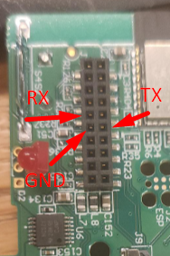

2.3 Digital Input Simulation
The four DI channels emulate discrete field devices. They may be used as steady ON/OFF signals or as pulse outputs for water-meter simulation. In the JSON interface, water-meter simulation is represented by the WM channel type.
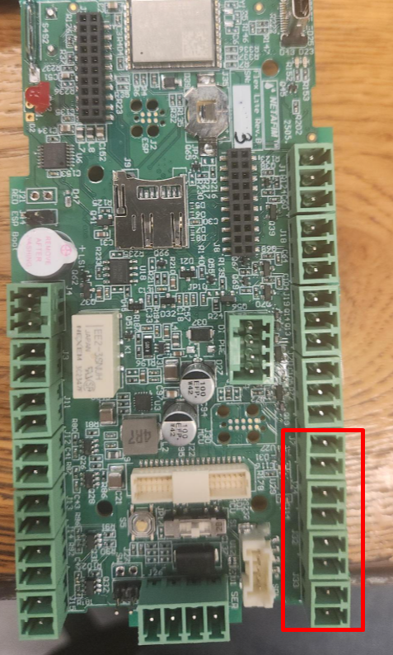

2.4 Analog Channel Connection
Each of the four analog channels contains GND, AO and AI connections. GND is the common reference, AO is the tester analog output, and AI is the tester analog measurement input. The channels are separate, so an AO/VAI output is not automatically present at the corresponding AI input unless the required external wiring is installed.
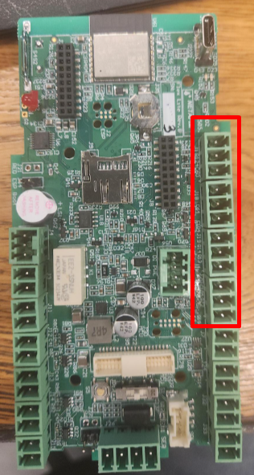
Important: The analog input is intended for 0-10 V measurement through the input-conditioning circuit. The connected test setup must provide more than 1 V at the relevant input when the automatic output behavior is expected to activate. Confirm polarity and share GND before applying voltage.

3. Starting the API and Sending JSON Files

3.1 Terminal 1 - Start the Server
Open PowerShell and run:
cd "C:\Users\o29373\OneDrive - Netafim\Desktop\Netafim Projects\ONE PRO 3 TESTER"
python ".\New folder\ONETesterApi.py" serve --port COM16 --http-port 8765
Expected result: the local tester API starts. Keep Terminal 1 open and running. The serial side uses COM16 and the local HTTP service listens on port 8765.

3.2 Terminal 2 - Send a JSON File
Open a second PowerShell window, move to the same project directory, and send the required JSON file:
cd "C:\Users\o29373\OneDrive - Netafim\Desktop\Netafim Projects\ONE PRO 3 TESTER"
python ".\New folder\ONETesterApi.py" send ".\New folder\ONETesterApi.examples.json" --new-id

3.3 Check the Connection
'{"id":"s1","action":"status","args":{"refresh":true}}' | python .\New folder\ONETesterApi.py send - --new-id

3.4 Safe Shutdown
python ".\New folder\ONETesterApi.py" send ".\New folder\ONETesterApi.examples.safe-off.json" --new-id
After the safe-off request completes, return to Terminal 1 and press Ctrl+C to stop the server.

4. JSON Request Structure
Field | Meaning
RequestId | Unique identifier for the complete request. It is used to match the response and help prevent duplicate execution.
Commands | Array of operations that are executed in their listed order.
Port | Channel type: VAI, WM.
PortNum | Channel number from 1 to 4.
Action | Operation to execute on the selected channel.

5. Channel Types
Channel | Meaning
VAI | Voltage supply output for the simulated sensor.
WM | Water-meter simulation output, including steady states and periodic pulses.

6. Available Actions
Action | Meaning
VAI Configure | Updates the channel settings without activating the output.
VAI On | Activates the output using the stored settings.
VAI Off | Turns the voltage output off.
VAI Pulse | Activates the output for a limited duration.
VAI Stop | Cancels an active pulse.
WM On | Sets a constant HIGH state.
WM Off | Sets LOW and turns the output off.
WM Start | Starts periodic pulse generation.
WM Stop | Stops pulse generation.

7. Voltage and Conversion Fields
Field | Meaning
Operation_Mode | Selects Manual or Automatic operation.
Manual_voltage | Requested manual voltage in millivolts, from 0 to 15000 mV.
X1 / Y1 / X2 / Y2 | Engineering conversion points used for linear scaling.
Output_Value | Engineering value used to calculate the required output voltage.

8. Timing Fields
Field | Meaning
Cycle_ms | Pulse period used by WM Start.
Duration_ms | Activation duration used by VAI Pulse or a timed WM operation.

9. Use of null and Zero
Value | Meaning
null in a non-relevant field | Allowed; the field is ignored for that action.
null in a required field | Validation error.
0 in Manual_voltage | A real zero-voltage setting, not a missing value.

10. Important Technical Notes
- Automatic mode is an engineering-value-to-voltage conversion mechanism. It is not an automatic mode controlled directly by VIN.
- VAI and AI are separate channels.
- AI is intended for 0-15 V measurements through the input-conditioning circuit.
- Always connect a common GND between the tester and the device under test.
- Before applying a signal, verify the permitted voltage range and polarity for the connected hardware.

11. Quick Operating Checklist
- Connect UART: TX to RX, RX to TX, and GND to GND.
- Connect USB Type-C power.
- Connect the required DI and/or analog channels.
- Confirm that the tester is assigned to COMXXX, or update the command.
- Start the server in Terminal 1 and leave it running.
- Send the JSON file from Terminal 2.
- Review the returned status or error message.
- Send safe-off before stopping the server.

